**Gas Pressure Sensor (GPSN-100)**

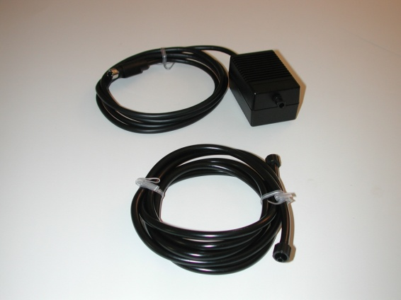**Overview**

The iWorx Gas Pressure Sensor (GPSN-100) can be used to measure the pressure of gasses within a range of 20 to 250 kPa. It can be used with the iWorx Blood Pressure Cuff (BP-220) for blood pressure experiments and with the iWorx Pressure Bulb (FT-220) for grip strength experiments.

**Figure 1**. GPSN-100 Gas Pressure Sensor and A-BT-220 connector tubing

**Background**

Gas pressure sensors are commonly used in a variety of applications from biomedical, to manufacturing, and maintenance. Using the Blood Pressure Cuff you can measure the pressure of blood flowing through your arteries and veins…

**Specifications**

|  |  |
| --- | --- |
| Sensor Input Range | 20 – 250 kPa |
| Output Voltage Range | 0.2 to 4.8V |
| Default Calibration Set Points | Vout for 101 kPa is 1.86V Vout for 114 kPa is 2.13V |
| Sensor Accuracy (Default Scaling) | ±10 kPa |

**Note:** 1kPa ≈ 7.5 mm Hg

**Note:** Calibrating the sensor on each use can provide more accurate measurements.

**Set Up & Calibration Procedure**

1. Connect the IX-myDAQ sensor adaptor to an NI myDAQ device.
2. Connect the Gas Pressure Sensor to the IX-myDAQ sensor adaptor.
3. Connect the myDAQ to your computer using a USB cable.
4. Connect the Blood Pressure Cuff (BP-220) using the connector tubing (A-BT-220) to the Gas Pressure Sensor (GPSN-100).
5. Open the LabVIEW data logging application, select the channel that the GPSN-100 is plugged into.
6. Ensure the manometer gauge on the blood pressure cuff is at 0mmHg. Record this voltage as Set Point 1.
7. Using the manometer gauge apply 200mmHg ensure it is steady and record this voltage as Set Point 2

*Note: If using the IX-myDAQ the signal may be inverted.

**Measurement Procedure**

**For use with the BP-220**

**For General Readings:**

1. Follow the calibration procedure outlined above.

**For use with the FT-220**

1.Follow the calibration procedure outlined above.

**Safety**

* This sensor is not intended for the diagnosis, cure, mitigation, treatment, or prevention of disease.
* Do not use this sensor to measure the pressure of caustic gasses.
* This sensor is not designed to measure the pressure of fluids.

**Software**

This sensor is designed to work with NI LabVIEW software. Download a pre-built data logger and a sensor API at **ni.com/minisystems**

**Support**

This sensor and its accessories are supported by iWorx Systems Inc.

Contact iWorx Technical Support

support@iworx.com

(800) 549-5748  
Support hours are 8:30 a.m. to 4:30 p.m. (EST), Monday through Friday.

iWorx Systems Inc. instruments, components, and accessories are designed for educational and research oriented life science applications and investigations. Iworx Systems Inc. does not condone the use of its instruments for clinical medical applications. Instruments, components, and accessories provided by Iworx Systems Inc. are not intended for the diagnosis, cure, mitigation, treatment, or prevention of disease.

© March 2014 iWorx All rights reserved

iWorx Systems, Inc. Phone: (800) 234-1757

62 Littleworth Road Fax: (603) 742-2455

Dover, NH 03820 iworx.com